Working with Github and Github Desktop

Table of Contents

1. Joining the repo 1

2. Setting up Github Desktop 1

3. How to work with Github Desktop 2

4. Connecting Ren’Py to the right project folder 2

# Joining the repo

To join the repo, create an account on Github.com and send your email or username to Vygan.

You can see the repo here: <https://github.com/DannyVanIets/wolfskin>

# Setting up Github Desktop

Download Github Desktop from here: <https://desktop.github.com/>

Login with your freshly created Githhub account.

To add the repo, you can click on “Current repository” > “Add” > “Clone Repository” and then search for “DannyVanIets/wolfskin” and click on “Clone”.

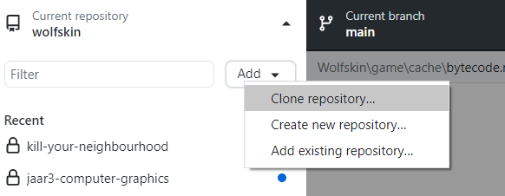

Just ignore the red text.

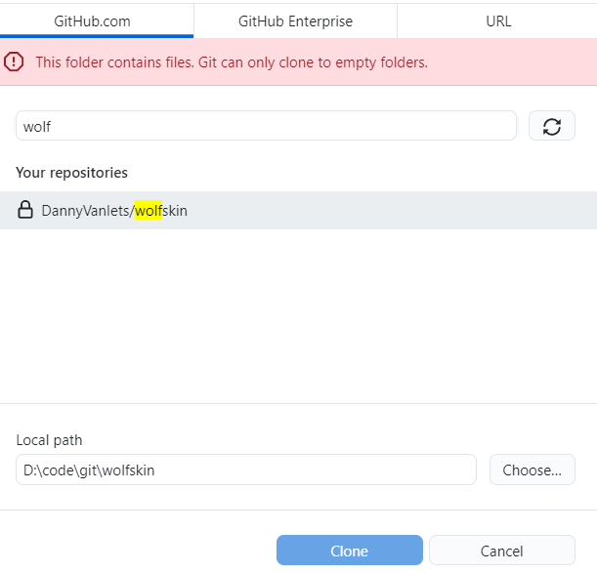

You can also do it with the website, just click on green button called “Code” > “Open with GitHub Desktop” > “Clone”.

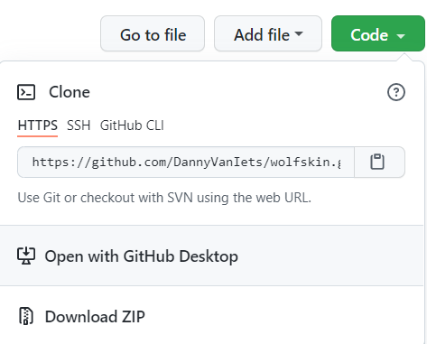

# How to work with Github Desktop

In the top left corner, you can see your current repository.

Right from current repo you’ve the current branch. If you click on this, you can see a list of branches and easily switch between branches.

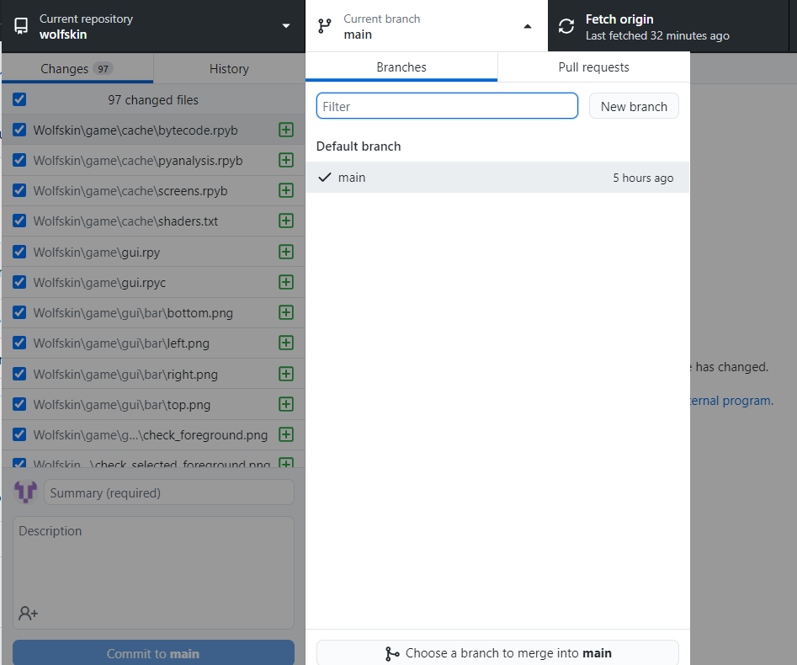

Right from “Current branch” is “Fetch origin”. If you click on this, it will check if you’ve any commits you need to pull. If you do, it will say “Pull origin” with the amount of commits there have been since your last pull.

# Connecting Ren’Py to the right project folder